Food Delivery Order Fulfillment Process Improvement
Business Analysis Case Study
Industry: Online Food Delivery
Case Study Organization: Zomato
Project Type: Business Process Improvement
Role: Business Analyst — Portfolio Case Study
Case Study Basis: Publicly available Zomato information
Disclaimer: This is an independent portfolio case study based on publicly available Zomato information and does not represent an internal Zomato project or use confidential company data.
1. Industry Evidence & Case-Study Assumptions
Industry evidence: This case study is informed by publicly available information about real-world food-delivery operations. Zomato's public technical and operational material describes several interconnected stages of food delivery, including restaurant order acceptance, food preparation, “Order Ready” status, delivery-partner assignment, pickup, delivery tracking and ETA calculation. Zomato also explains that accurate preparation-time and delivery-time estimation is important for customer experience and can influence customer-support workload.[1]
Case-study approach: The project uses these publicly documented industry practices as the basis for analyzing an order-fulfillment process and proposing business improvements. The analysis does not claim access to Zomato's internal systems, confidential operational data, proprietary algorithms or internal performance reports.
Assumptions : Where quantitative baseline values are required for process-improvement planning, they are explicitly treated as case-study assumptions, not as actual Zomato performance figures. Proposed targets will be used to demonstrate KPI definition, SLA design and measurable business outcomes.

References
[1] Zomato, “The Deep Tech Behind Estimating Food Preparation Time,” 2020.
https://www.zomato.com/blog/food-preparation-time/
[2] Zomato Developer Platform, “Restaurant Confirms Order on Zomato logistics,” updated May 26, 2026.
https://www.zomato.com/developer/integration/docs/getting-started/development-for-integration/live-order-flow/restaurant-confirms-order/zomato-logistics/
2. Business Problem Statement:
The food-delivery customer journey depends on coordinated execution across multiple operational stages, including restaurant order acceptance and preparation, delivery-partner dispatch and pickup, delivery tracking, and final handover. Publicly documented industry practices show that food preparation time, delivery-partner timing, ETA accuracy, order tracking, and delay communication are closely connected to the customer delivery experience.
This case study investigates how an online food-delivery platform can improve its order-fulfillment process by identifying operational bottlenecks, strengthening real-time visibility, introducing proactive exception handling, and defining clear escalation mechanisms.
The focus is on improving delivery reliability and customer experience while reducing avoidable operational workload caused by delayed or poorly communicated orders.
Case-study basis: This is an industry-informed Business Analysis simulation based on publicly available information. It does not use confidential internal data from Zomato, Swiggy, or any other company.
3. Business Objectives:
The objective of this process-improvement initiative is to redesign the food-delivery order fulfillment journey so that operational delays are identified earlier, customers receive more accurate and timely information, and operational teams can respond to exceptions before they become major service failures.
The proposed improvement will focus on four measurable outcomes:
O-01 — Improve Delivery Reliability
Reduce the assumed late-delivery baseline from 18% to below 5% within six months of implementation.
O-02 — Reduce Delay-Related Support Contacts
Reduce order-delay-related customer support contacts by 40% through proactive status updates and automated delay notifications.
O-03 — Reduce Fulfillment Cycle Time
Reduce the total order-to-delivery fulfillment cycle time by 15% through improved preparation monitoring and delivery-partner dispatch coordination.
O-04 — Reduce Avoidable Cancellations
Reduce operationally avoidable order cancellations by 25% through earlier exception detection, escalation and recovery actions.
Measurement note: The 18% baseline and percentage-reduction targets are assumed planning values for this portfolio case study, not actual internal performance figures from Zomato, Swiggy or another company.
4. Project Scope :
The project focuses on improving the end-to-end food-delivery order fulfillment process from order confirmation through final customer delivery. The analysis covers operational activities that directly influence delivery reliability, customer visibility, and exception handling.
In Scope
• Order confirmation and order-status lifecycle
• Restaurant preparation-time estimation and monitoring
• Delivery-partner assignment and dispatch timing
• Pickup and delivery status tracking
• Customer ETA visibility and proactive delay communication
• SLA monitoring and operational escalation
• Exception handling for delayed orders and rider drop-offs
• Process improvement recommendations for delivery operations
Out of Scope
• Restaurant onboarding and menu management
• Pricing, discounts and promotional strategy
• Delivery-partner payroll, compensation and incentives
• Payment gateway infrastructure and financial reconciliation
• Detailed route-optimization algorithms
• Broader marketing and customer-acquisition strategy
Scope boundary: The initiative is limited to the operational order-to-delivery journey and the business processes that support reliable fulfillment. It does not attempt to redesign the entire food-delivery platform.

5. Stakeholder Analysis :
Stakeholder | Role in Process | Key Needs / Concerns | Influence | Engagement
Customer | Places and receives the order | Accurate ETA, order visibility, timely updates, issue resolution | Medium | High
Restaurant / Merchant | Accepts and prepares the order | Realistic preparation times, smooth order handling, timely rider arrival | High | High
Delivery Partner | Picks up and delivers the order | Accurate pickup timing, efficient dispatch, clear delivery information | Medium | High
Customer Support | Handles complaints and delivery issues | Accurate order visibility, fewer repetitive delay contacts, clear escalation path | Medium | High
Operations Team | Monitors delivery performance and exceptions | SLA compliance, lower delays/cancellations, operational visibility | High | High
Product / Technology Team | Supports process/system changes | Clear requirements, priorities, business rules and acceptance criteria | High | High

6.As-Is Process Map :
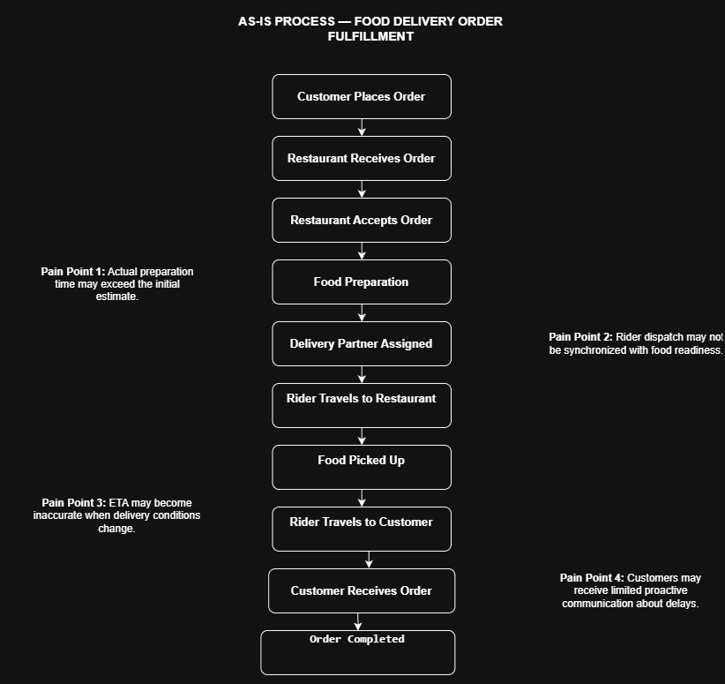
Figure 1. Current-state food-delivery order fulfillment process and identified operational pain points.

The current-state process contains multiple handoffs between the customer, restaurant, delivery partner and operations ecosystem. The identified pain points provide the basis for the subsequent root-cause and gap analysis.

7. Root Cause & Gap Analysis:

The As-Is process highlights several points where delays, inaccurate delivery expectations and communication gaps can affect the customer journey. The analysis below identifies the likely root causes and the capability gaps that the improved process should address.

ID | Pain Point | Likely Root Cause | Business Impact | Capability Gap
P1 | Preparation takes longer than estimated | Preparation estimates may not reflect current restaurant workload or operating conditions | Delivery delays | Dynamic preparation-time monitoring
P2 | Rider assignment is not synchronized with food readiness | Dispatch timing is not sufficiently linked to preparation progress | Rider waiting and slower fulfillment | Coordinated dispatch logic
P3 | ETA becomes inaccurate when conditions change | ETA is not recalculated quickly enough | Customer frustration and loss of trust | Dynamic ETA recalculation
P4 | Customers learn about delays late | Delay communication is reactive | More support contacts and dissatisfaction | Proactive customer notifications
P5 | Operations reacts after a problem occurs | Limited automated SLA monitoring and escalation | Higher support workload and slower recovery | Exception monitoring and SLA escalation
P6 | Rider drops an order after acceptance | Exception/reassignment workflow is not clearly defined | Further delay and cancellation risk | Standardized reassignment and recovery workflow
Key finding: The main improvement opportunities are concentrated in three capability areas: real-time visibility, coordination between restaurant preparation and delivery-partner dispatch, and proactive exception management.

8. To-Be Process Map :
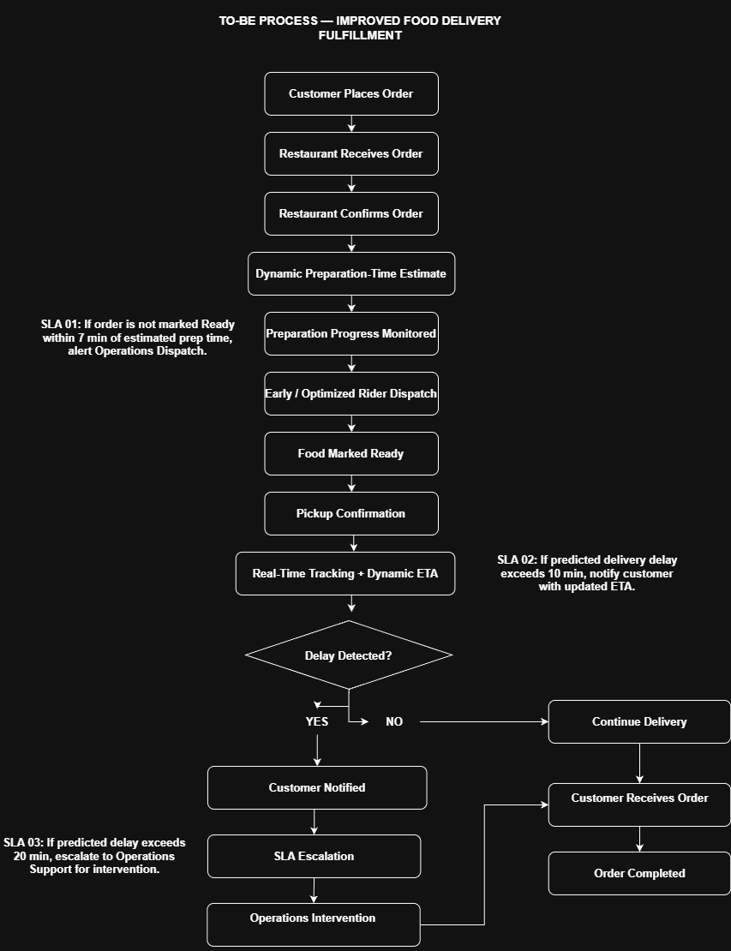
Figure 2. Proposed future-state food-delivery order fulfillment process with proactive monitoring and SLA-based escalation.

The proposed process introduces dynamic preparation monitoring, coordinated delivery-partner dispatch, real-time ETA updates, proactive customer communication, and SLA-based operational escalation. The design aims to move delivery operations from a reactive, complaint-driven model toward proactive exception management.

9. Business Requirements
Based on the identified process gaps and the proposed future-state workflow, the following business requirements define the capabilities needed to improve delivery reliability, customer visibility, operational response, and exception management

ID | Business Requirement | Priority | Success Measure
BR-01 | Provide reliable visibility of the order status throughout the fulfillment lifecycle. | High | Customers and operations can access the current order status.
BR-02 | Monitor restaurant preparation progress against the estimated preparation time. | High | Preparation delays are detected before they materially affect delivery.
BR-03 | Improve coordination between food readiness and delivery-partner dispatch. | High | Reduce rider waiting time and support the 15% fulfillment-cycle-time reduction target.
BR-04 | Provide customers with proactive notifications when meaningful delivery delays occur. | High | Support contacts related to order delays reduced by the 40% target.
BR-05 | Establish SLA-based escalation for orders at risk of significant delay. | High | Breached thresholds trigger timely operational intervention.
BR-06 | Provide a standardized recovery process for rider drop-offs and other delivery exceptions. | Medium | Exceptions are reassigned or escalated through a defined workflow.
BR-07 | Improve overall delivery reliability. | High | Reduce the assumed late-delivery baseline from 18% to below 5%.
BR-08 | Reduce avoidable operational cancellations. | Medium | Achieve the proposed 25% reduction target.
Requirement note: These requirements define the business capabilities needed from the improved process. Specific system behaviors and implementation details will be defined separately in the Functional Requirements section.

10. Functional Requirements

The functional requirements translate the approved business requirements into specific system and process behaviors. These requirements describe how the proposed solution should monitor orders, update delivery information, communicate with stakeholders, and respond to operational exceptions.
ID | Functional Requirement | Related Business Requirement | Priority
FR-01 | The system shall display the current status of an active order throughout the fulfillment lifecycle. | BR-01 | High
FR-02 | The system shall record and monitor the estimated restaurant preparation time for each order. | BR-02 | High
FR-03 | The system shall compare actual preparation progress with the estimated preparation time. | BR-02 | High
FR-04 | If an order is not marked Ready within 7 minutes of the estimated preparation time, the system shall generate an alert for Operations Dispatch. | BR-02, BR-05 | High
FR-05 | The system shall coordinate delivery-partner assignment based on expected food readiness and delivery timing. | BR-03 | High
FR-06 | The system shall update the estimated delivery time when relevant order or delivery conditions change. | BR-01 | High
FR-07 | If the predicted delivery delay exceeds 10 minutes, the system shall notify the customer and provide the updated ETA. | BR-04 | High
FR-08 | If the predicted delivery delay exceeds 20 minutes, the system shall escalate the order to Operations Support. | BR-05 | High
FR-09 | If a delivery partner drops an accepted order before completion, the system shall flag the order for priority reassignment. | BR-06 | Medium
FR-10 | The system shall maintain an exception status for orders requiring operational intervention. | BR-05, BR-06 | High
FR-11 | The system shall provide Operations with visibility of orders approaching or exceeding defined SLA thresholds. | BR-01, BR-05 | High
FR-12 | The system shall record notification and escalation events for operational monitoring and audit purposes. | BR-04, BR-05 | Medium

SLA requirement note: The 7-minute, 10-minute and 20-minute thresholds are proposed operating rules for this case study. They are not stated as existing Zomato internal thresholds.
Requirement quality check: Each functional requirement is written to be specific, observable and testable, allowing the proposed solution to be validated during User Acceptance Testing.

11. User Stories
User stories translate the identified business and functional requirements into clear statements of stakeholder needs. Each story follows the Agile format: As a [user], I want [capability], so that [business value].

ID | User Story | Stakeholder | Priority | Related FR
US-01 | As a customer, I want to view my current order status so that I know where my order is in the fulfillment process. | Customer | High | FR-01
US-02 | As a restaurant, I want to update preparation progress so that the delivery process can respond to changes in readiness time. | Restaurant | High | FR-02, FR-03
US-03 | As an operations user, I want to receive an alert when preparation exceeds the defined threshold so that I can intervene before the order becomes significantly delayed. | Operations | High | FR-04
US-04 | As a delivery partner, I want dispatch timing to reflect expected food readiness so that I can minimize unnecessary waiting at restaurants. | Delivery Partner | High | FR-05
US-05 | As a customer, I want my ETA to update when delivery conditions change so that I have a more accurate expectation of arrival. | Customer | High | FR-06
US-06 | As a customer, I want to receive a notification when my order is significantly delayed so that I can make informed decisions about my order. | Customer | High | FR-07
US-07 | As an operations user, I want severely delayed orders to be escalated automatically so that critical delivery issues receive timely intervention. | Operations | High | FR-08, FR-11
US-08 | As an operations user, I want a dropped order to enter a priority reassignment workflow so that another delivery partner can be assigned quickly. | Operations | Medium | FR-09
US-09 | As an operations user, I want exceptions to be recorded with their status so that I can track and manage unresolved delivery issues. | Operations | High | FR-10, FR-12
US-10 | As a customer-support agent, I want visibility into order status and delay events so that I can resolve customer queries without relying on manual information gathering. | Customer Support | Medium | FR-01, FR-11, FR-12

Traceability note: Each user story is linked to one or more functional requirements to maintain traceability between the business need, proposed solution behavior and stakeholder requirement.

12. Acceptance Criteria

ID | Related User Story | Acceptance Criteria
AC-01 | US-01 — Customer order visibility | Given an active order, when the customer opens order tracking, then the current order status is displayed accurately.
AC-02 | US-02 — Restaurant preparation updates | Given an accepted order, when preparation progress changes, then the updated preparation status/time is recorded.
AC-03 | US-03 — Preparation delay alert | Given an order is not marked Ready within 7 minutes of the estimated preparation time, when the threshold is reached, then an Operations Dispatch alert is generated.
AC-04 | US-04 — Coordinated dispatch | Given an order has an estimated readiness time, when dispatch planning occurs, then rider assignment considers expected food readiness.
AC-05 | US-05 — Dynamic ETA | Given delivery conditions change materially, when the revised delivery estimate is calculated, then the customer sees the updated ETA.
AC-06 | US-06 — Customer delay notification | Given the predicted delay exceeds 10 minutes, when the threshold is reached, then the customer receives a delay notification containing the updated ETA.
AC-07 | US-07 — Critical escalation | Given the predicted delay exceeds 20 minutes, when the threshold is reached, then the order is escalated to Operations Support.
AC-08 | US-08 — Rider drop recovery | Given a rider drops an accepted order before completion, when the drop event is recorded, then the order enters the priority reassignment workflow.
AC-09 | US-09 — Exception tracking | Given an order requires intervention, when an exception occurs, then the exception status and relevant event are recorded for operational tracking.
AC-10 | US-10 — Support visibility | Given a customer contacts support, when the support agent opens the order, then relevant order status and delay events are available.
Acceptance-criteria note: The criteria are designed to be observable and testable. The proposed 7-minute, 10-minute and 20-minute SLA thresholds are case-study assumptions rather than actual internal Zomato rules.

13. User Acceptance Testing (UAT) & Edge Cases
User Acceptance Testing (UAT) validates whether the proposed process and requirements support the intended business outcomes. The scenarios below cover both standard operating conditions and common exception cases that could affect delivery reliability and customer experience.

ID | UAT Scenario | Test Condition | Expected Result | Priority
UAT-01 | Normal order flow | The customer places an order and the restaurant prepares it within the estimated time. | Order progresses through all stages and reaches successful delivery. | High
UAT-02 | Restaurant preparation delay | Order is not marked Ready within 7 minutes of estimated preparation time. | Operations Dispatch receives an SLA alert. | High
UAT-03 | Significant delivery delay | Predicted delivery delay exceeds 10 minutes. | Customer receives a delay notification with updated ETA. | High
UAT-04 | Critical delivery delay | The predicted delay exceeds 20 minutes. | Order is escalated to Operations Support for intervention. | High
UAT-05 | Rider drops order | The assigned rider drops the order before completion. | Order enters priority reassignment workflow. | High
UAT-06 | Repeated prep-time changes | The restaurant updates preparation time multiple times. | ETA is recalculated and the latest valid estimate is reflected in the order status. | Medium
UAT-07 | GPS signal loss | The rider loses GPS connectivity during active delivery. | Last known location is retained and the exception is flagged without falsely marking the order as delivered. | Medium
UAT-08 | Customer-support inquiry | Customer contacts support about a delayed order. | Support agent can view current status, delay events and latest ETA. | Medium
UAT-09 | Restaurant cancellation after acceptance | The restaurant cancels after accepting an order. | An exception is recorded and the appropriate recovery/cancellation workflow is triggered. | High
UAT-10 | Successful recovery after intervention | Operations resolves a delayed order. | Order resumes delivery and reaches completed status without duplicate escalation. | Medium

UAT acceptance principle: A scenario is considered successful when the expected business outcome is achieved and the system/process behavior is consistent with the approved requirements and acceptance criteria.
14. Recommendations & Business Impact
Based on the As-Is process, root-cause analysis, identified capability gaps, and proposed To-Be process, the following recommendations are proposed to improve delivery reliability, customer visibility, and operational response.

ID | Recommendation | Problem Addressed | Expected Business Benefit
R-01 | Introduce dynamic preparation-time monitoring and update estimates as restaurant conditions change. | Preparation-time mismatch | More accurate delivery expectations
R-02 | Improve synchronization between food readiness and delivery-partner dispatch. | Rider waiting and dispatch delays | Lower fulfillment cycle time
R-03 | Implement dynamic ETA recalculation using current order and delivery conditions. | Inaccurate ETA | Better customer visibility and trust
R-04 | Introduce proactive customer notifications for significant delivery delays. | Reactive communication | Fewer delay-related support contacts
R-05 | Implement SLA-based monitoring and escalation using the proposed 7-, 10- and 20-minute thresholds. | Late operational response | Faster intervention and recovery
R-06 | Create a standardized recovery workflow for rider drop-offs and other delivery exceptions. | Unstructured exception handling | Lower cancellation and recovery risk
R-07 | Provide Operations and Support with a centralized view of order status, delay events and escalations. | Limited operational visibility | Faster decision-making and issue resolution

Expected Business Impact
The proposed improvements are expected to create measurable benefits across four key areas:
1. Delivery Reliability
The initiative targets a reduction in the assumed late-delivery baseline from 18% to below 5%.
2. Customer Experience
Proactive notifications and improved ETA accuracy are expected to reduce uncertainty and improve transparency during delivery.
3. Operational Efficiency
Better preparation monitoring, dispatch coordination and automated escalation are expected to support the proposed 15% reduction in fulfillment cycle time.
4. Support & Retention
Earlier communication and issue resolution are expected to reduce delay-related support contacts by 40% and support a 25% reduction in avoidable cancellations.
Measurement Framework
KPI | Baseline | Target | Measurement Approach
Late delivery rate | 18%* | <5% | % of eligible delivered orders completed after promised/estimated time
Delay-related support contacts | 100%* | −40% | Compare delay-related contact volume before vs. after rollout
Fulfillment cycle time | 100%* | −15% | Average time from order confirmation to completed delivery
Avoidable cancellations | 100%* | −25% | Compare operationally avoidable cancellation rate before vs. after rollout
Baseline values marked with an asterisk are assumed planning values for this portfolio case study and do not represent confidential or verified internal performance data from Zomato or another delivery platform.

